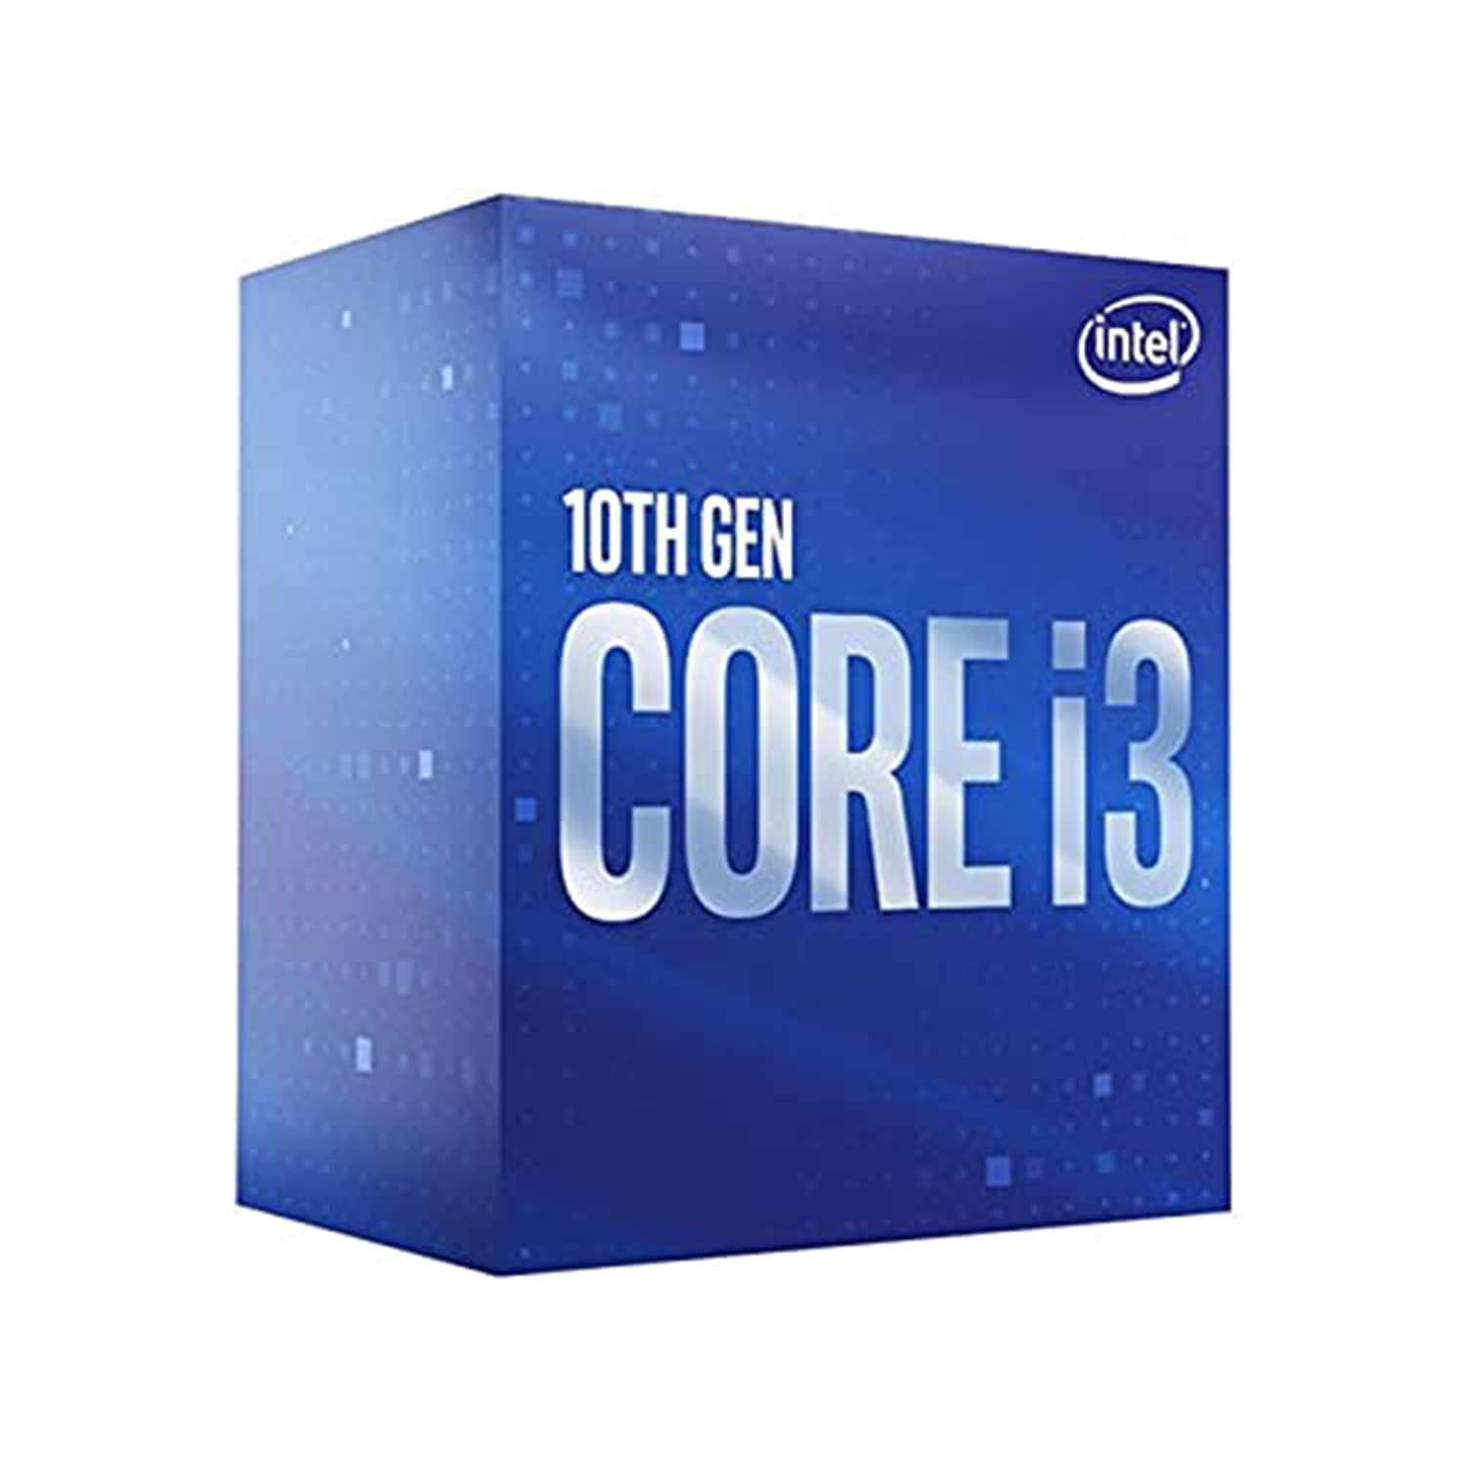

Inner

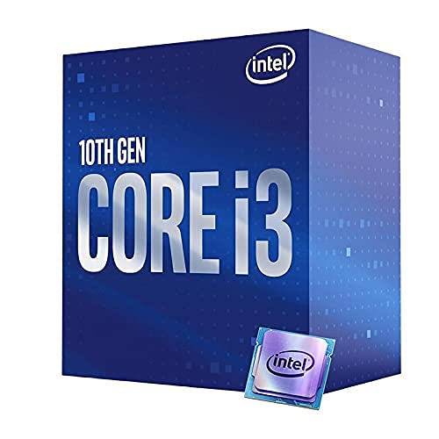

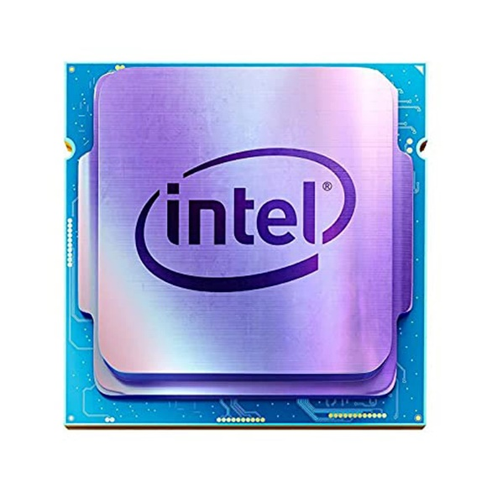

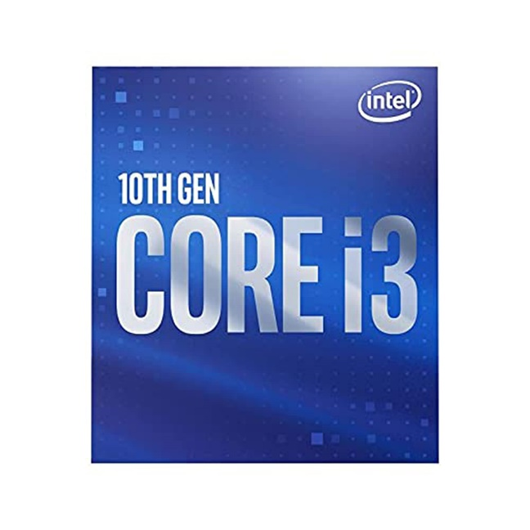

Intel Core i3-10100F 10th Generation LGA1200 Desktop Processor 4 Cores 8 Threads up to 4.30GHz 6MB Cache

-31% ₹6,600.00

M.R.P.: ₹9,500.00

|  |  |
| --- | --- |
| Brand | Intel |
| CPU Manufacturer | Intel |
| CPU Model | Core i3-10100F |
| CPU Speed | 4.3 GHz |
| CPU Socket | LGA1200 |

**About this item**

* Introducing the 10th Gen Intel Core i3 desktop processor, this processor comes in 14 nm, supports LGA 1200 socket and features 4 Core which allow the processor to run multiple programs simultaneously without slowing down the system. While the 8 threads allow instructions to be handled by a single CPU core alomg with Hyper Threading Technology.
* Programmed with 3.60GHz Base frequency, the Intel Turbo Boost 2.0 technology cranks maximum turbo frequency up to blazing 4.30 GHz. The processor is desirable for a gamer looking for a fantastic in-game experience and a creator that is ready to do more creating and sharing alike.
* All this paired with 6MB of Intel Smart Cache. It has a TDP rating of 65W with max memory size of 128GB dual-channel DDR4 support for up-to 2666Mhz with Intel top notch security features.
* Designed with Intel Optane memory, that can dramatically improve boot times and accelerate system performance in desktop PCs and laptops. It streamlines your computing experience by combining storage capacity and intelligent system acceleration.
* The processor extends all the capabilities that users love from previous generation CPUs with even more advanced innovations that deliver exciting new levels of performance when paired with the right graphics card.